Experiment: 5
Creating an amazon VPC.

- Login into AWS Account then Start Lab Launch AWS Console Home.
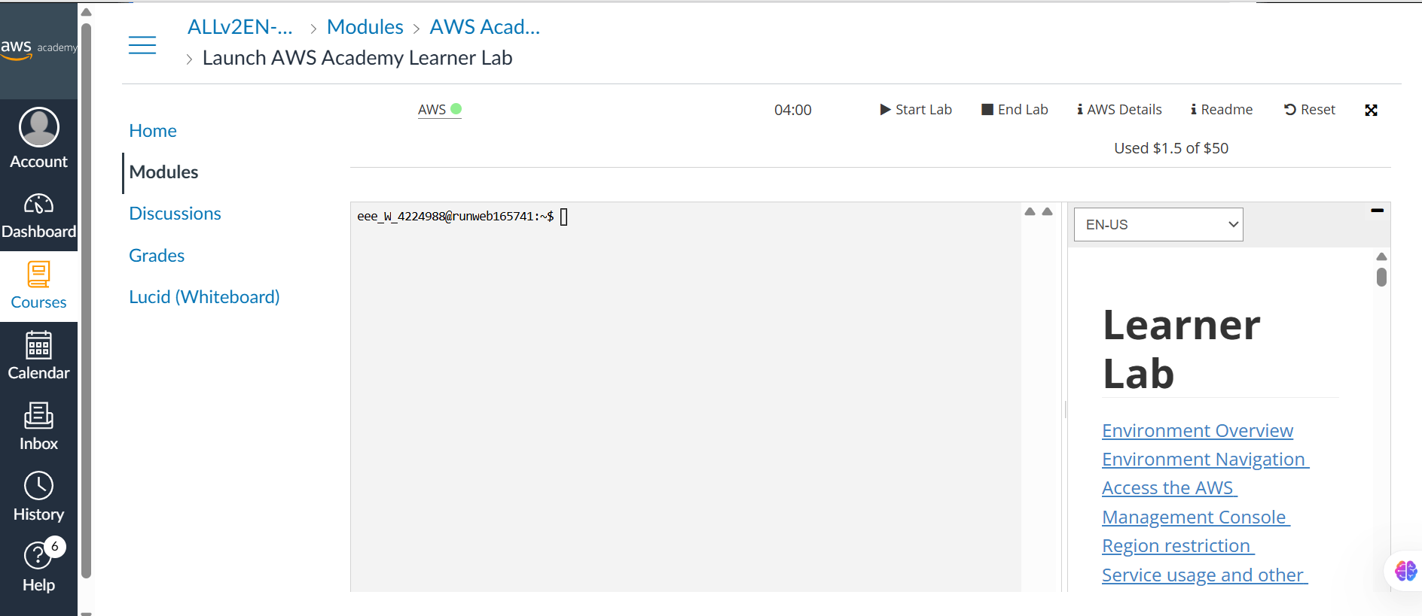

- Search VPC and select it in the search bar.
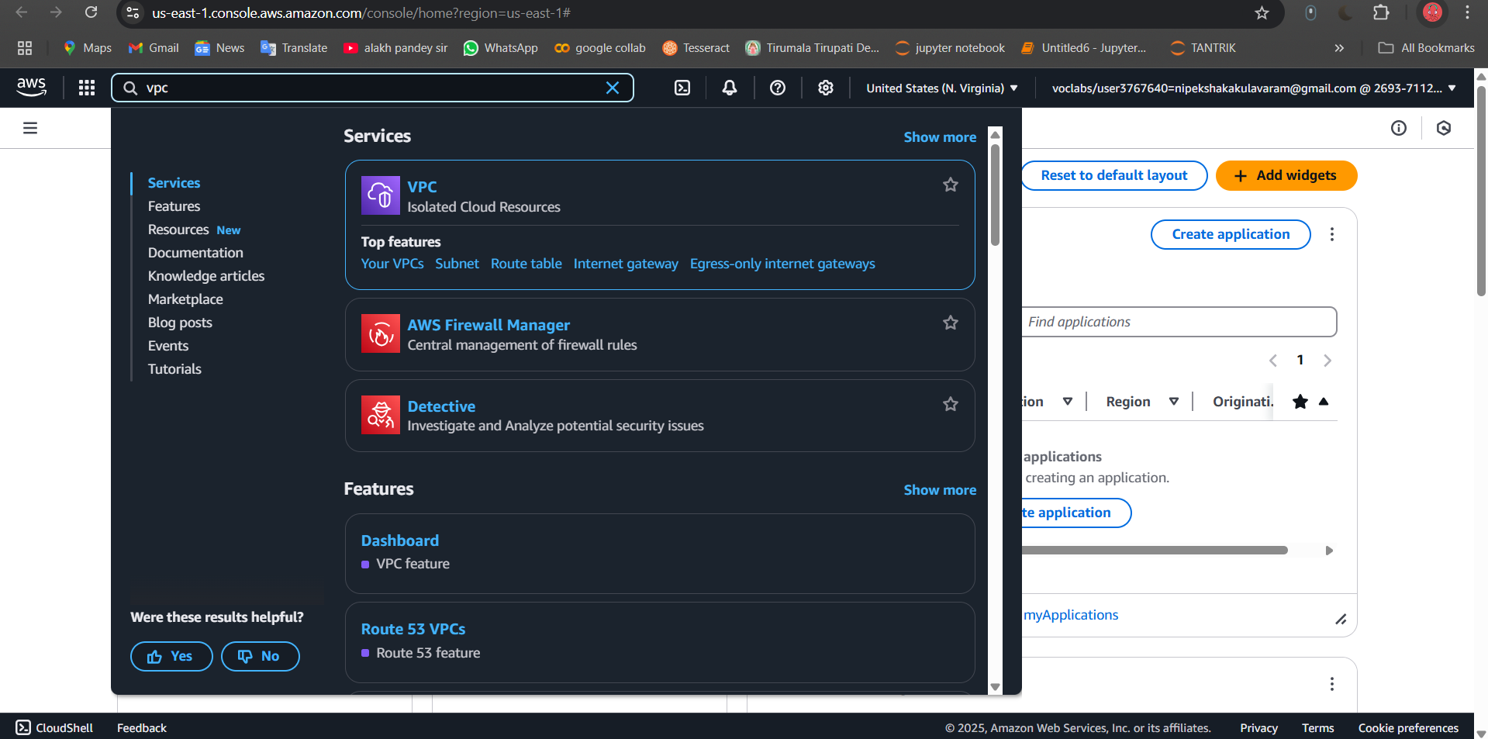

- Click VPC, you will navigate below UI
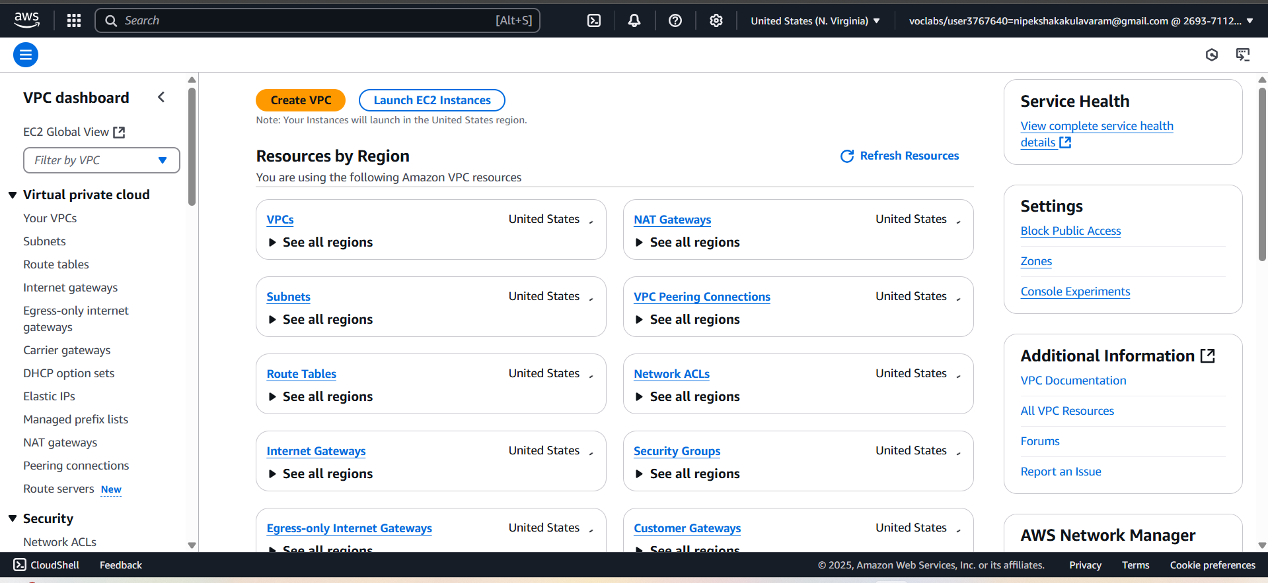

- Click on create VPC
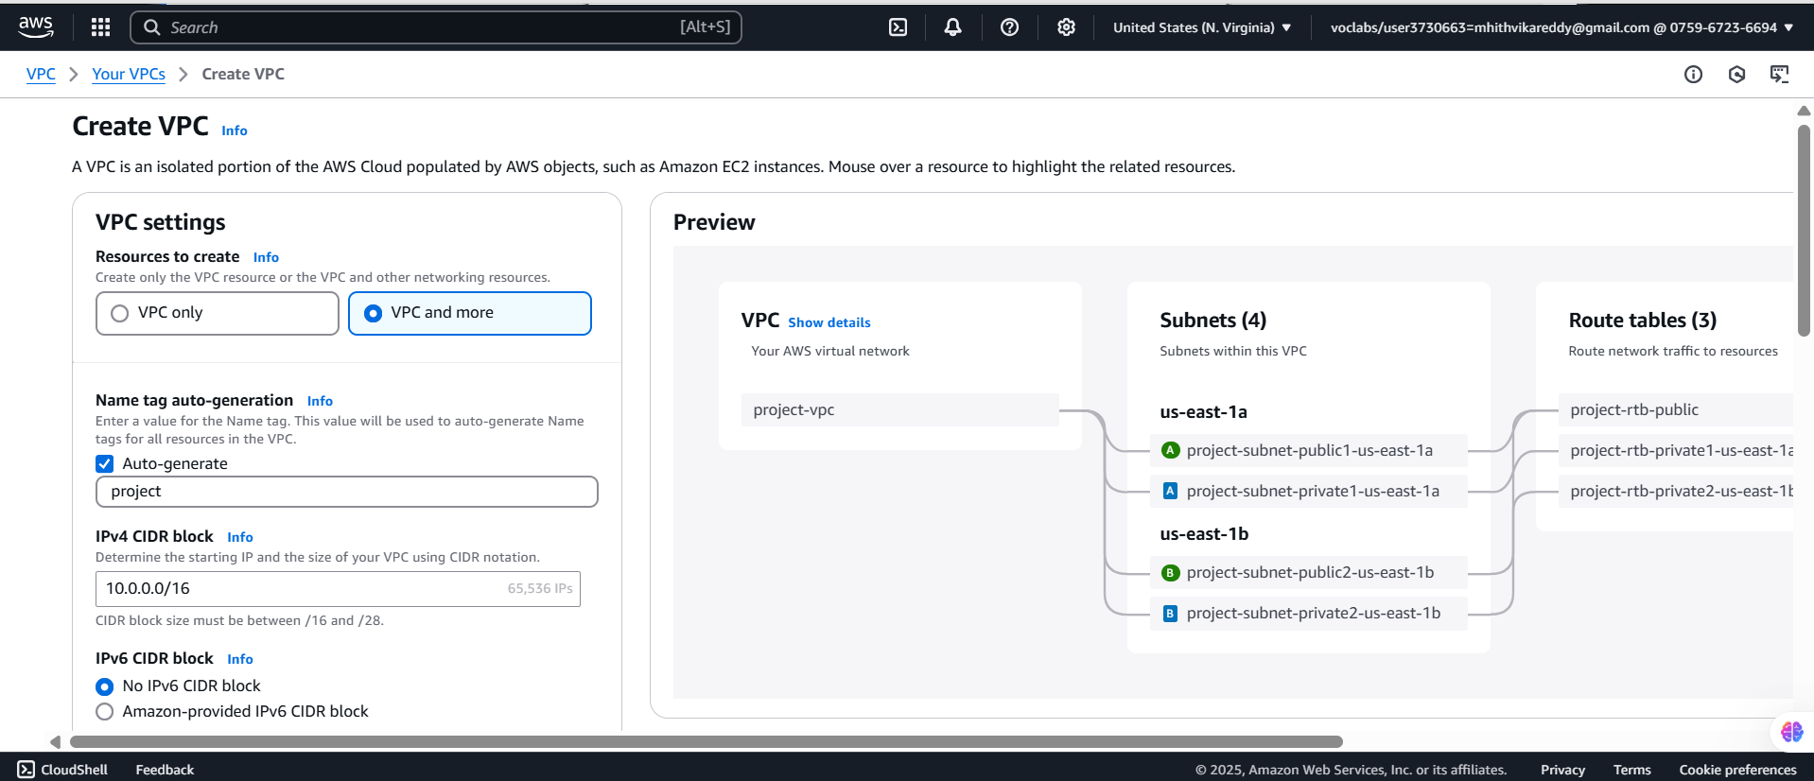

- Select VPC only
VPC Setting:
Resources to create: select Resources to create
Name tag - optional:
22bd1a057a-VPC
IPv4 CIDR block: IPv4 CIDR manual input
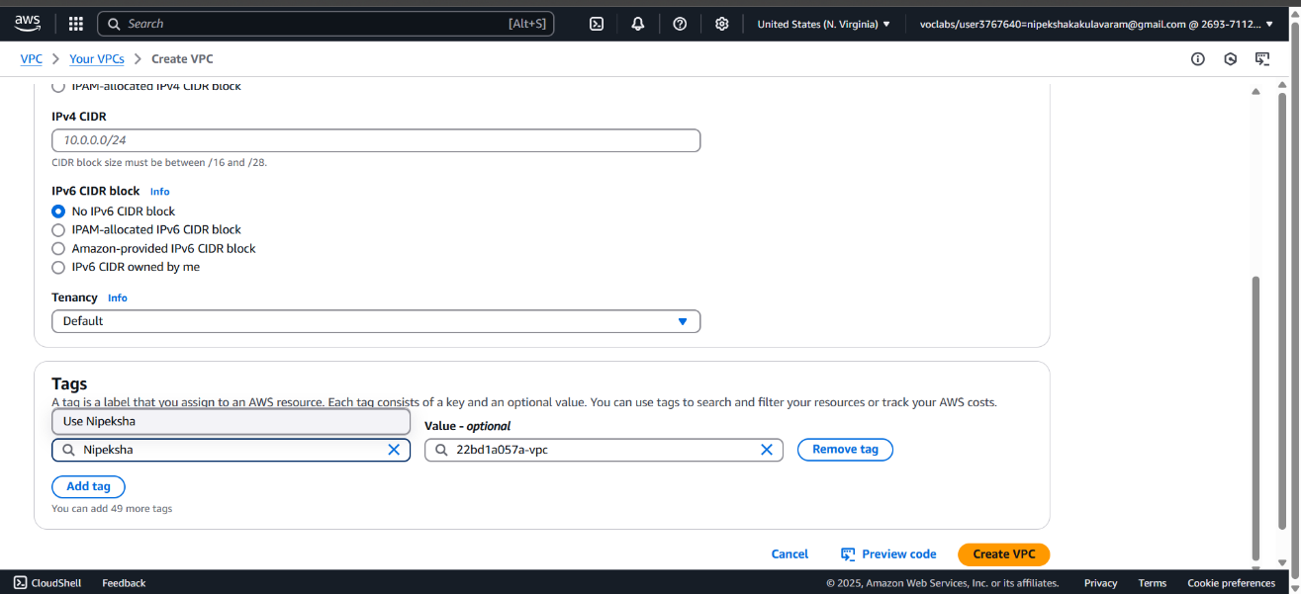

IPv4 CIDR: 12.0.0.0/16
IPv6 CIDR block: No IPv6 CIDR block
Tenancy: Default
Tags:
Key: Nipeksha
Value: 22bd1a057A-VPC
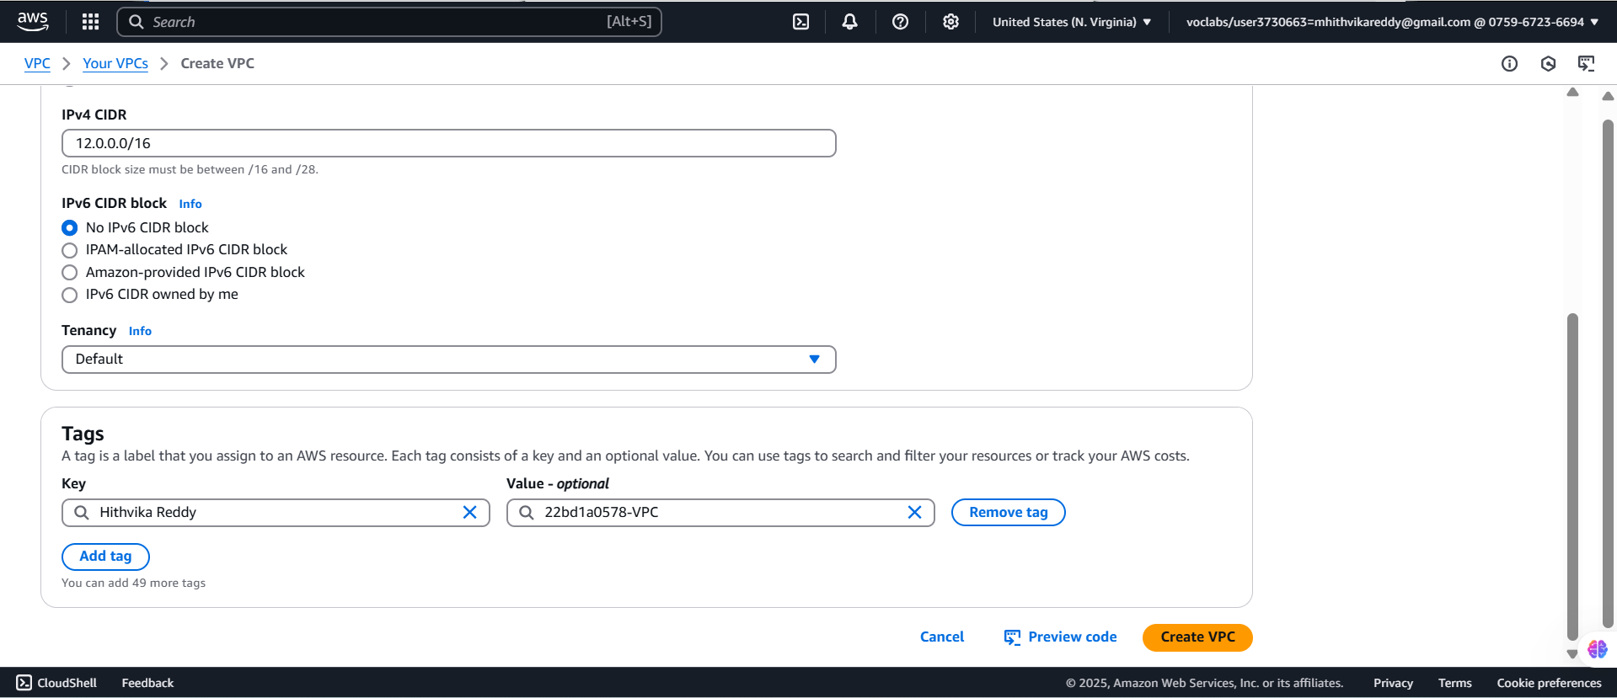

- Click on create VPC.
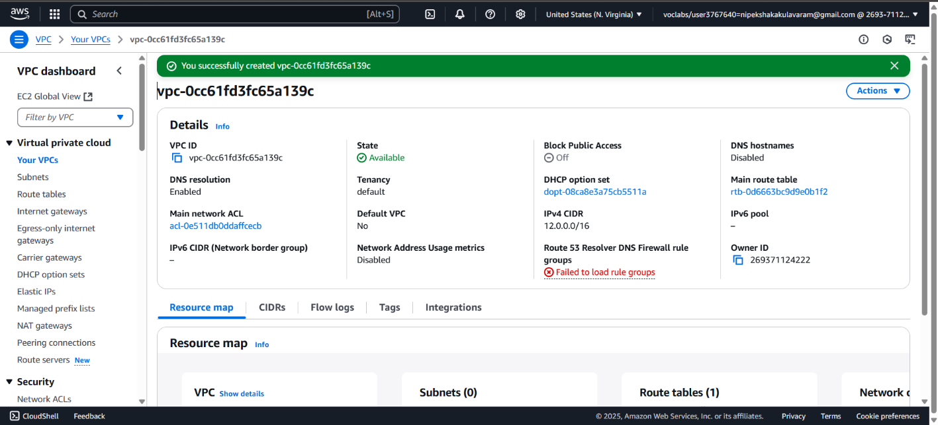

- Creating Internet Gateways
Click on Internet gateways at left side pallet
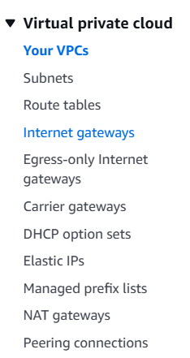

- Click on create internet gateway.
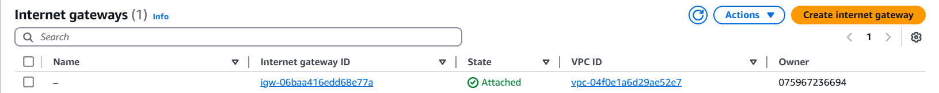

- Internet gateway settings:
Name tag: 22bd1a057a-IG
Tags - optional (Default)
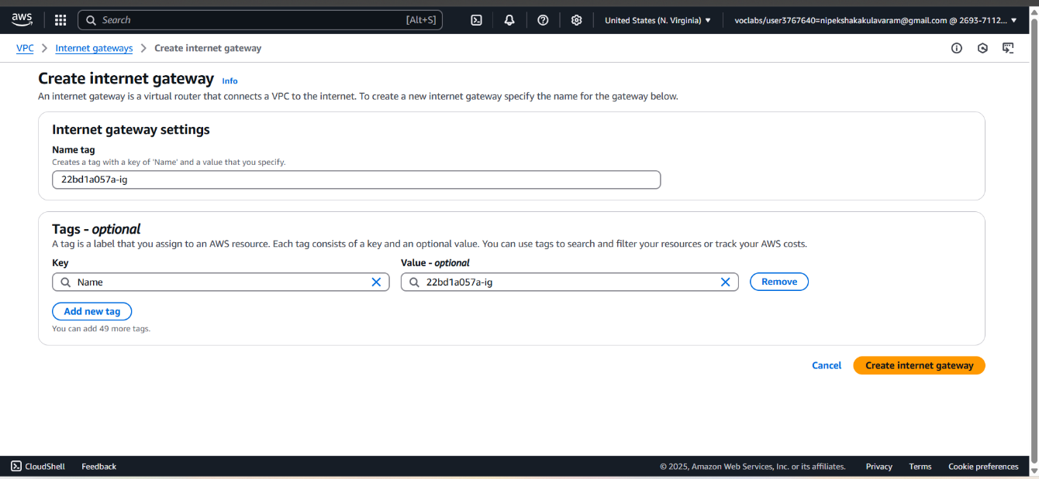

- Select your internet gateway Which is created
Click on Action → Attach to VPC → Select your VPC created above Step

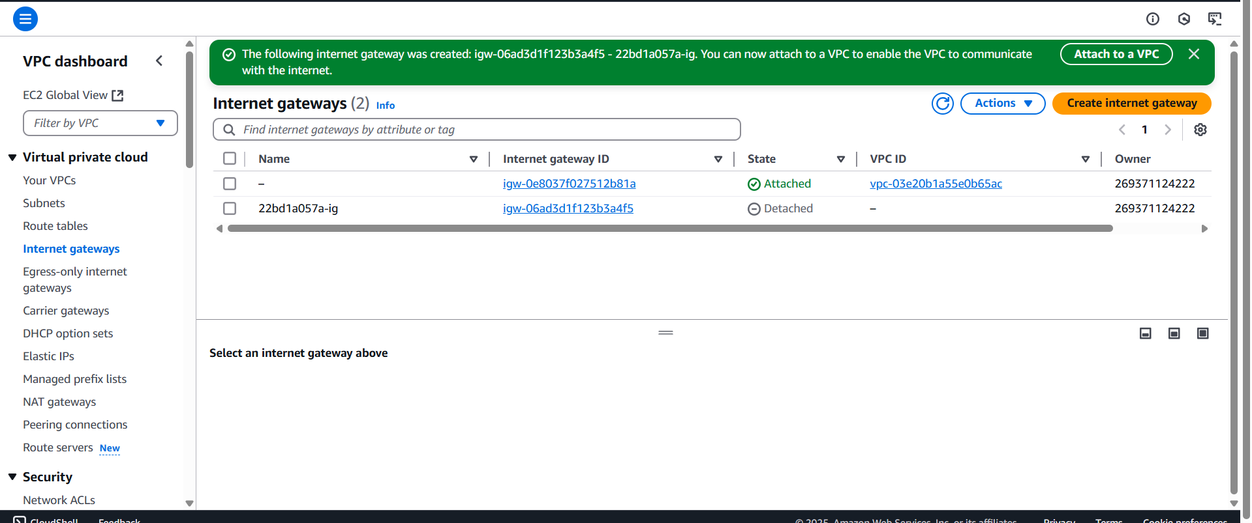

- Click on Attach to a VPC.
- 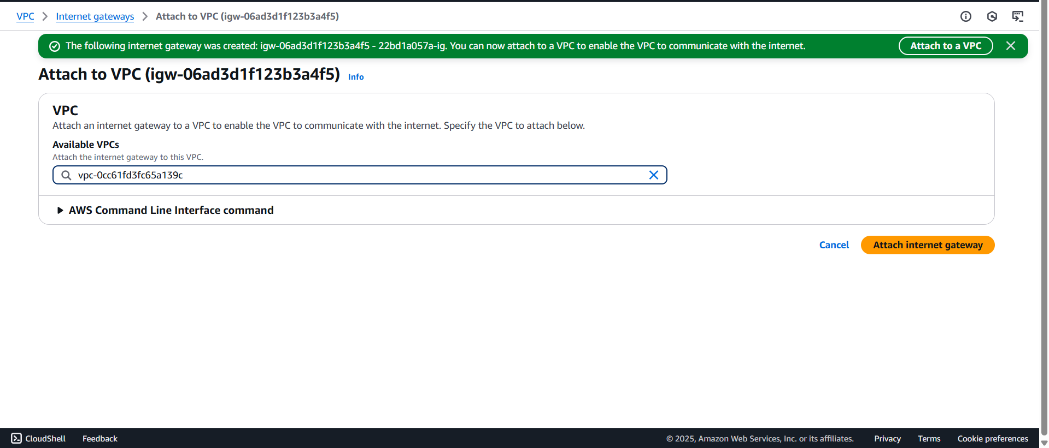

- Now your VPC has been attached successfully.

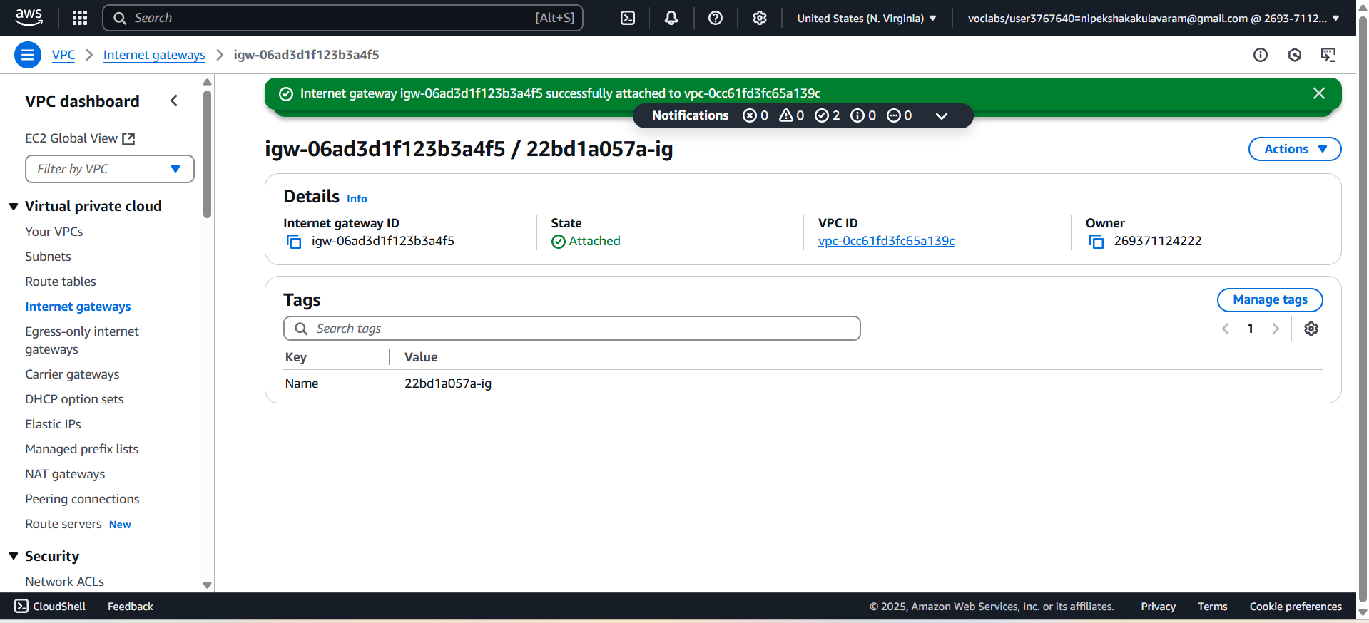

- Click on subnets (Left Panel):
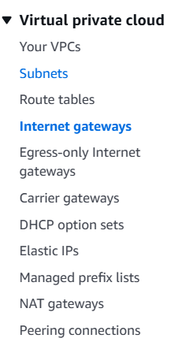

- Click on Create Subnets
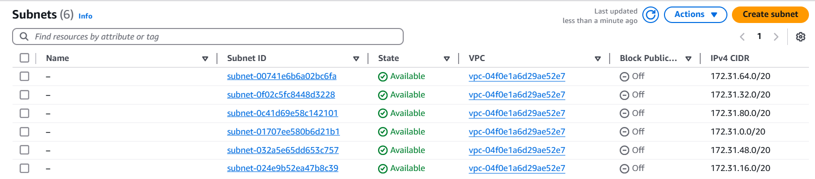

- Create subnet: Select your VPC created
Subnet settings:
Subnet 1 of 1
i. Subnet name: 22bd1a057a-public-SB1
ii. Availability Zone: Select US(N.Virgina) -us-east 1a
iii. IPv4 VPC CIDR block: 12.0.0.0/16
iv. IPv4 subnet CIDR block: 12.0.0.0/20
Keep all Default Tags

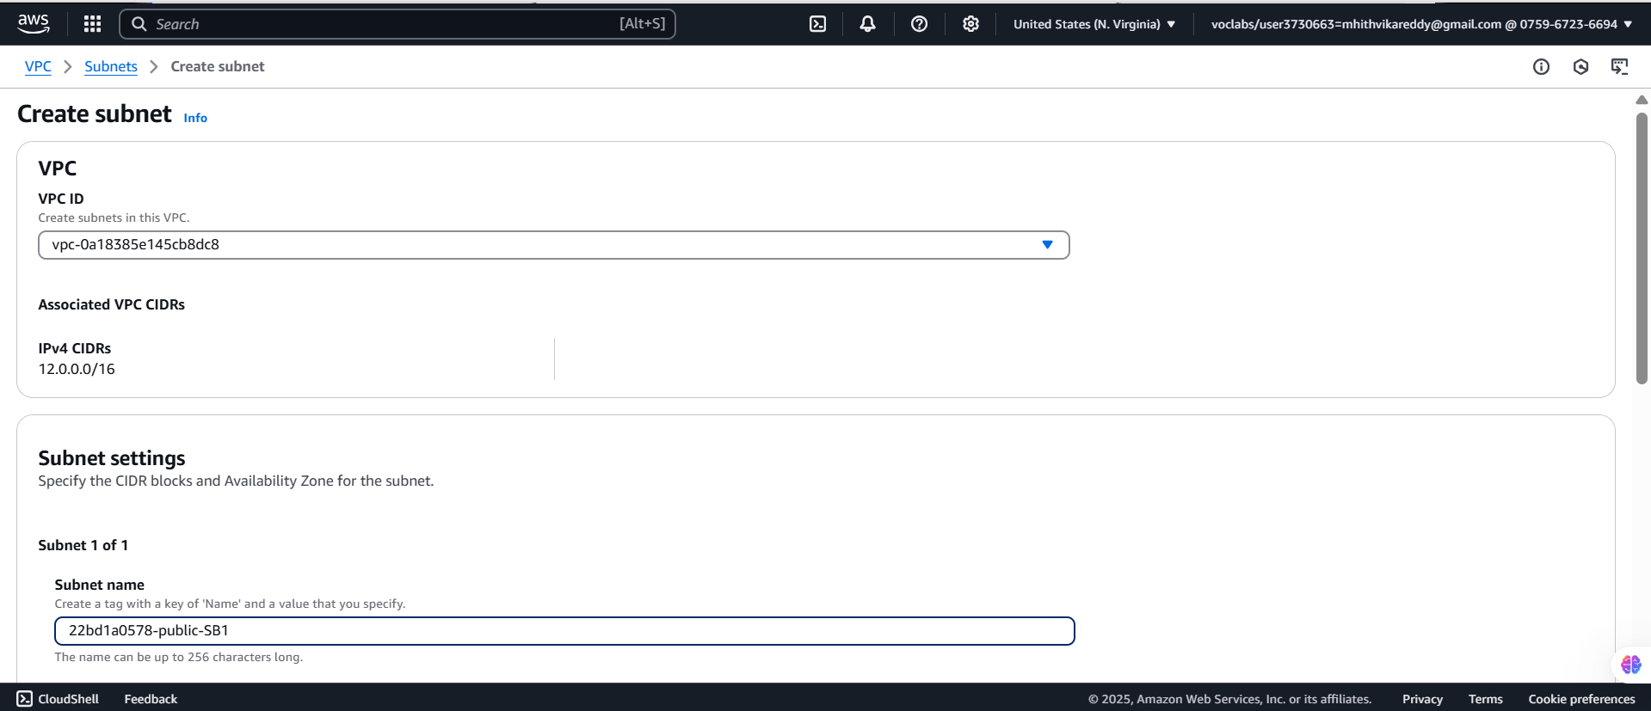

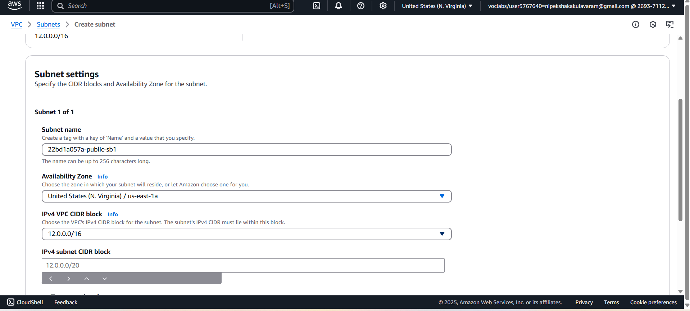

- Click on Add new Subnet
Subnet 2 of 2
i.Subnet name: 22bd1a057a-private-SB2
ii.Availability Zone: Select US(N.Virgina) -us-east 1a
iii.IPv4 VPC CIDR block: 12.0.0.0/16
iv.IPv4 subnet CIDR block: 12.0.16.0/20
Finally click on create subnet.

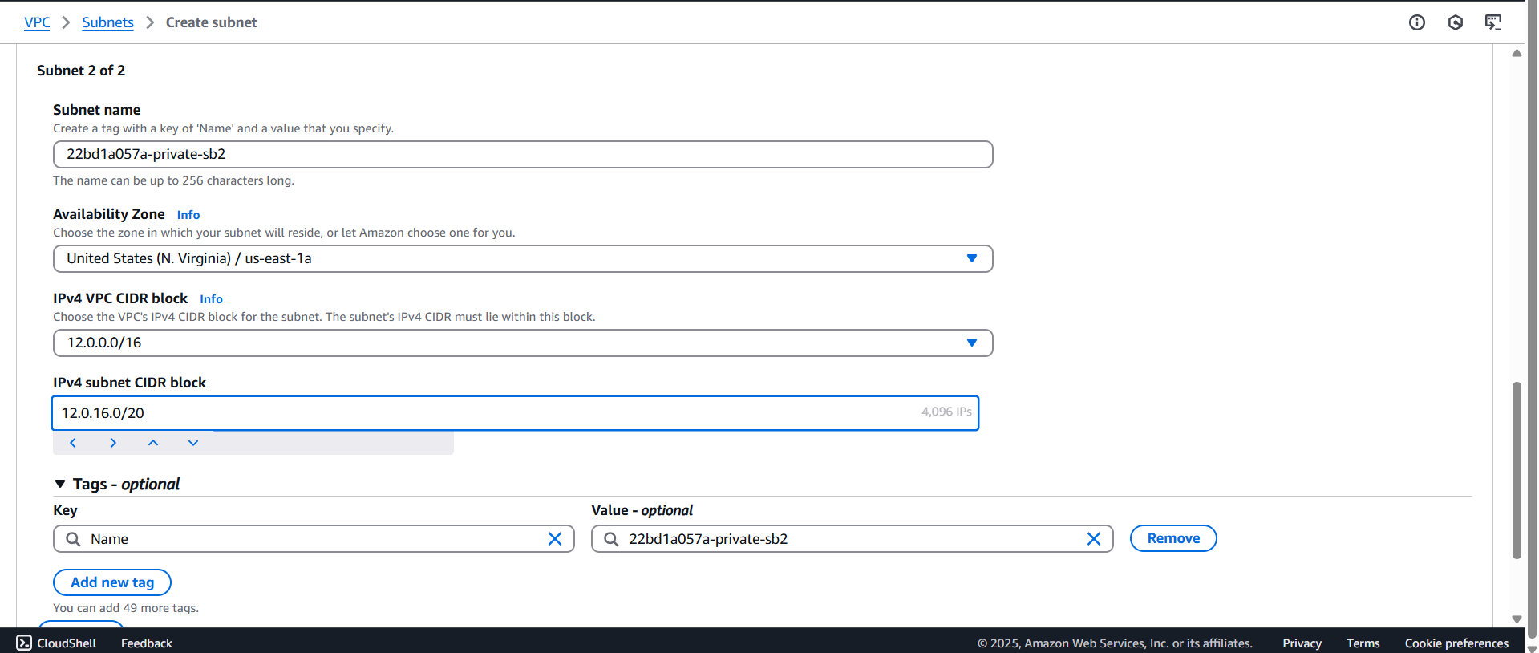

- Finally we can see the Subnets:

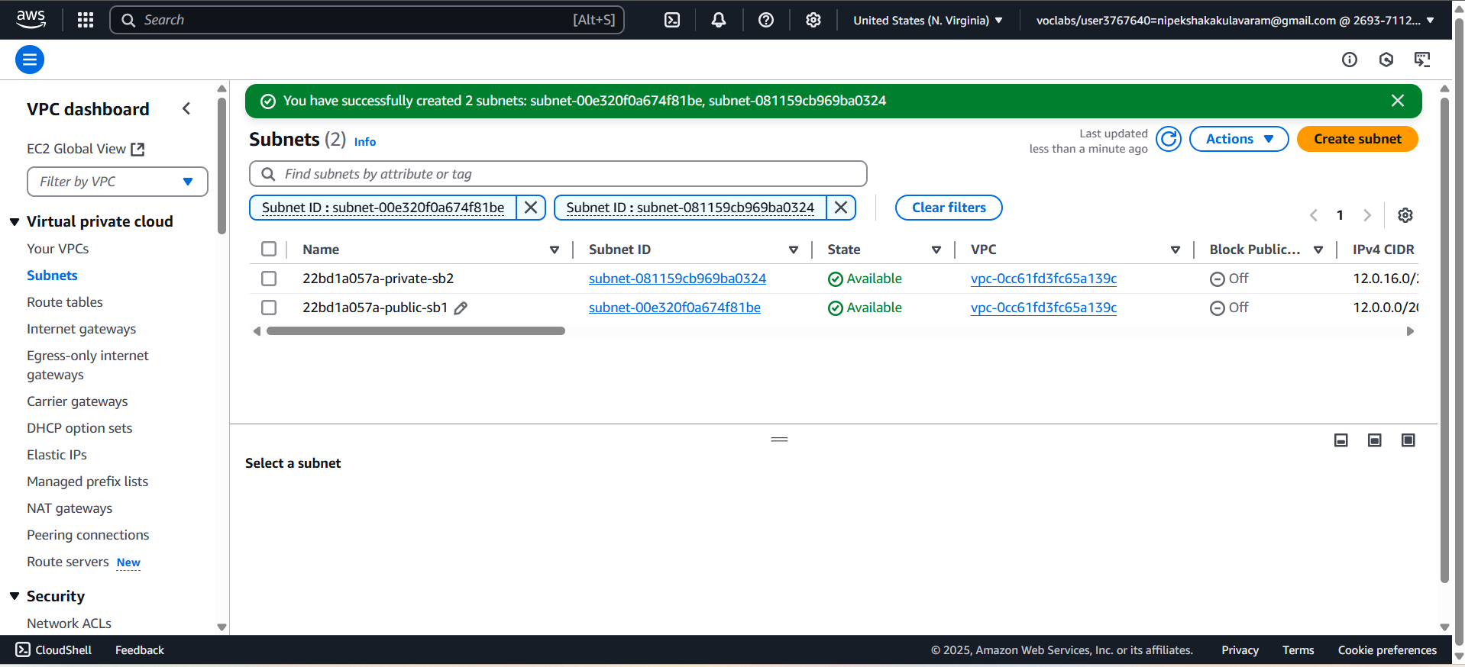

- Click on Route tables left side of pallet
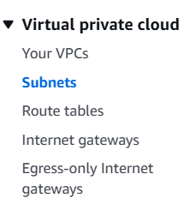

- Click on create route table.
- 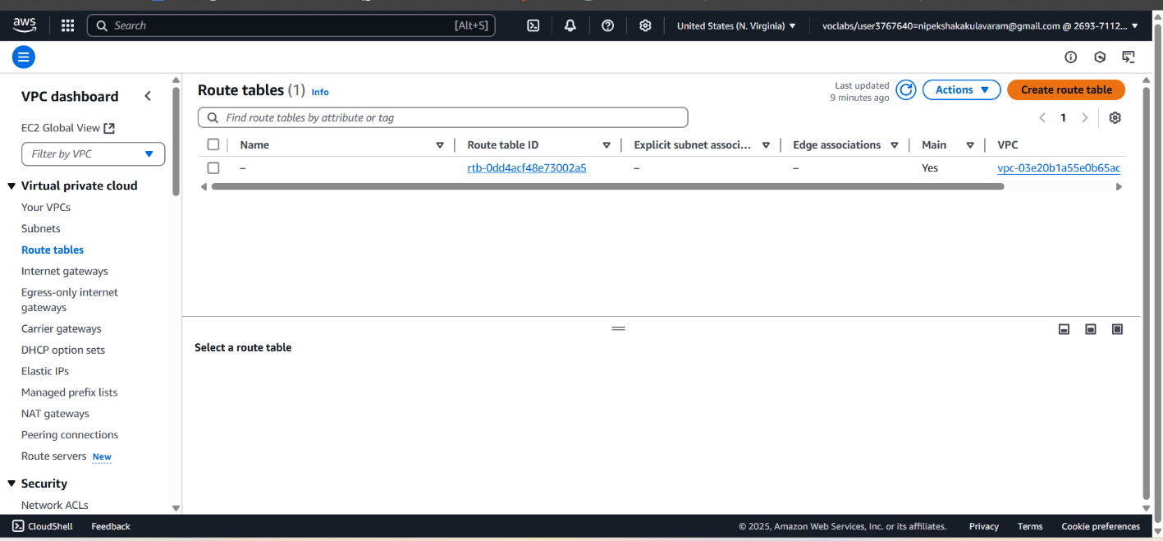

- Route table settings:
Name: 22bd1a057a-public-RT
VPC: Select your VPC created one
Tags: Default
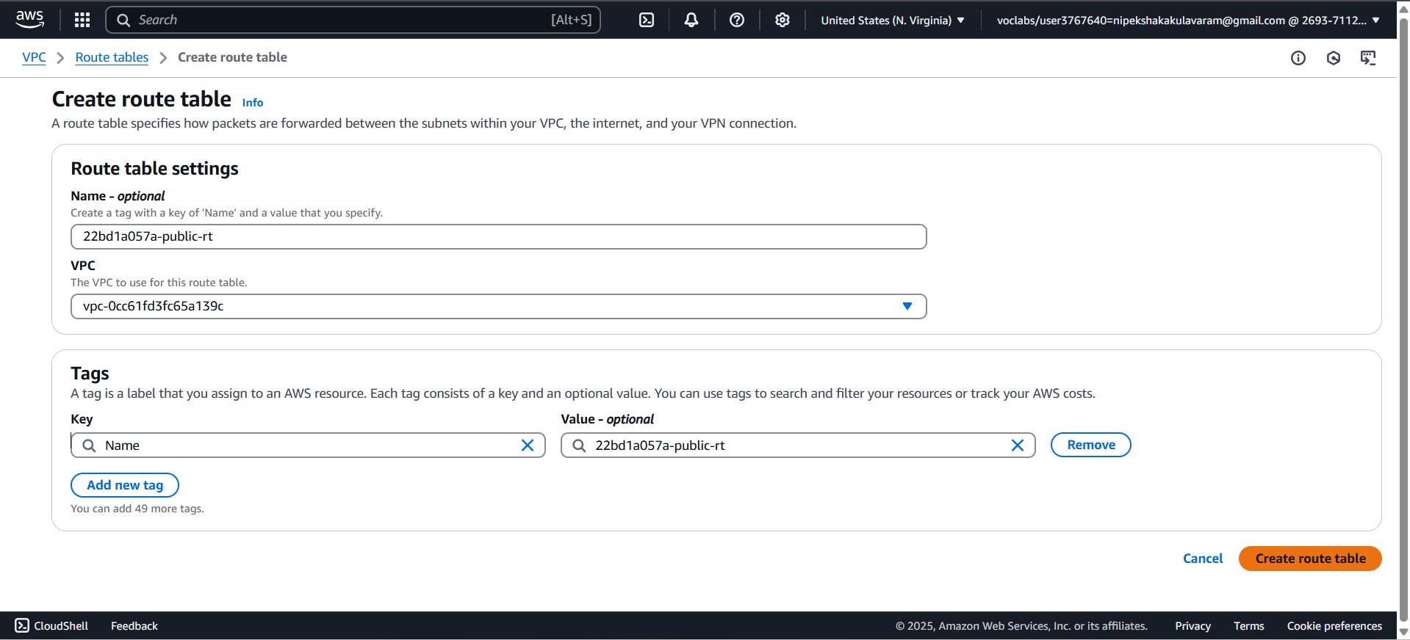

- Finally click on Create route Table
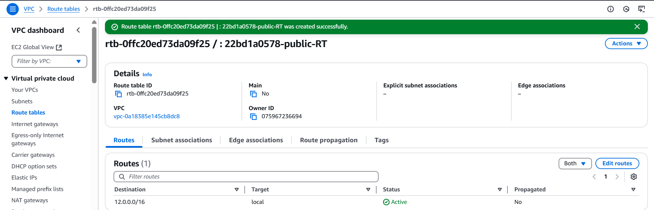

- We need to provide Internet to Route
I. Click on edit Route
II. click Add Route
0.0.0.0/0 (Internet)
Target (Internet Gateway)
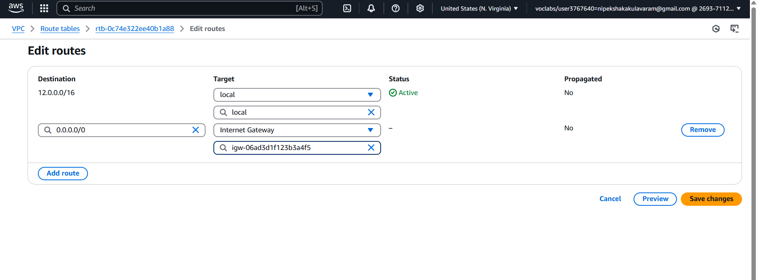

- Finally save changes
-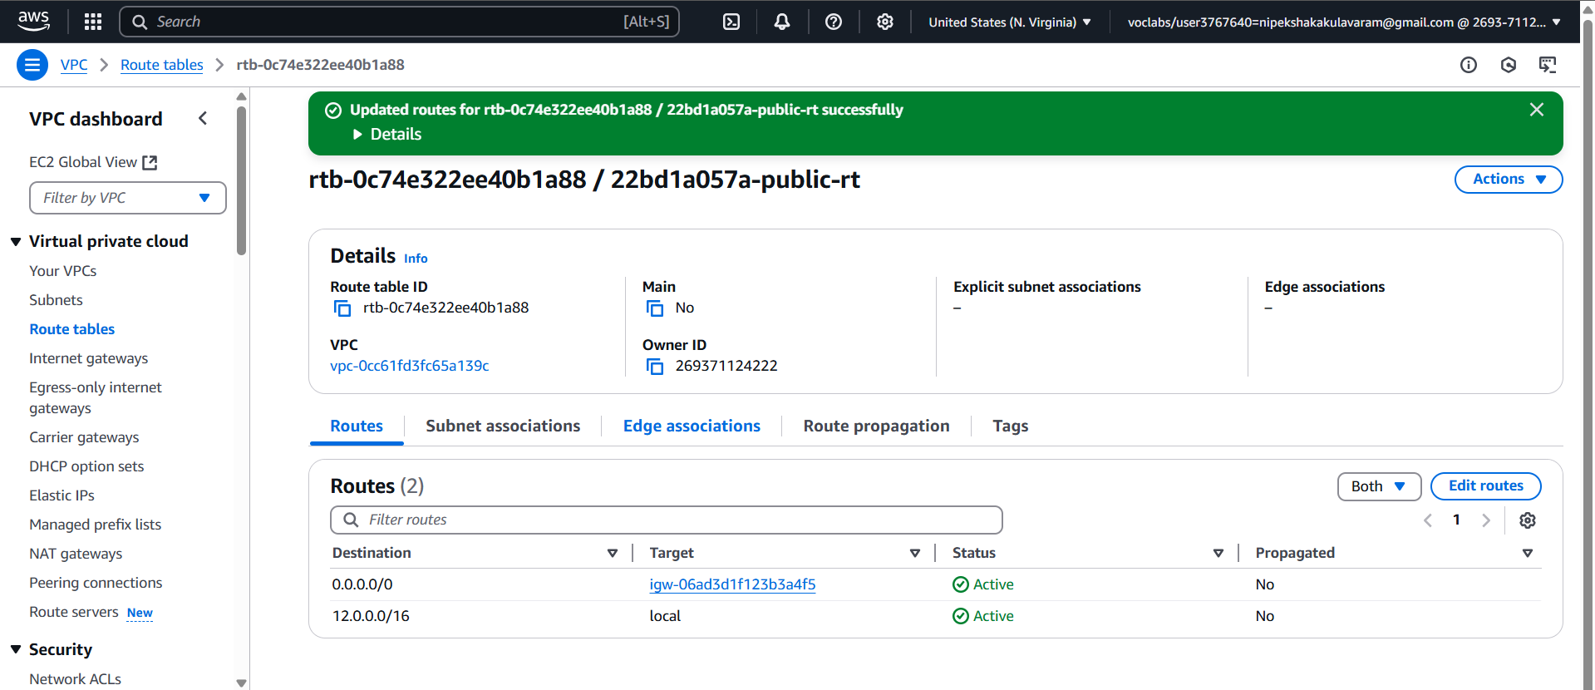

- In route tables click on subnet associations → Click edit subnet associations
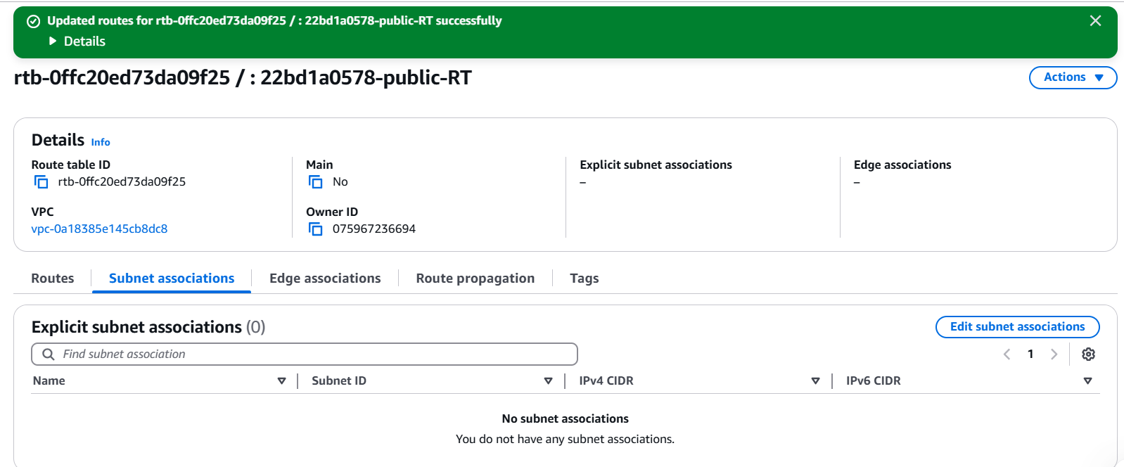

- Public RouteTable: To provide access to public route internet access SB-1 Select (Checkbox) & Save association.
- 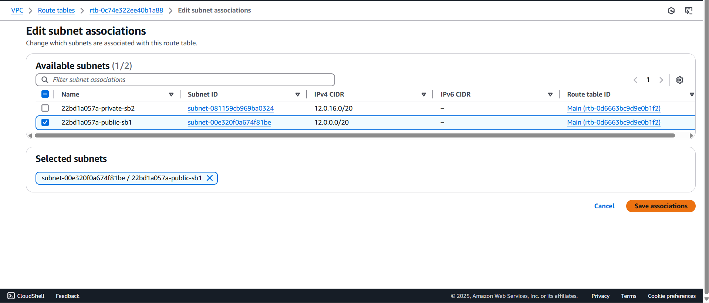

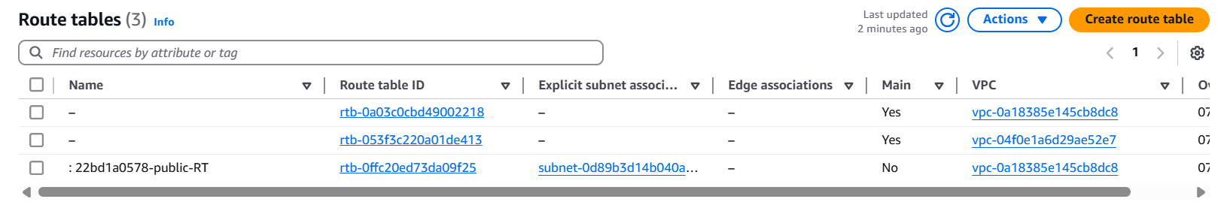
- Private Route Table: To provide access to Private route internet access SB-2
Go to route tables. Click & create a route Table
Name: 22bd1a057a-private-RT, VPC: Select your VPC, Tags: Default
Click create route table
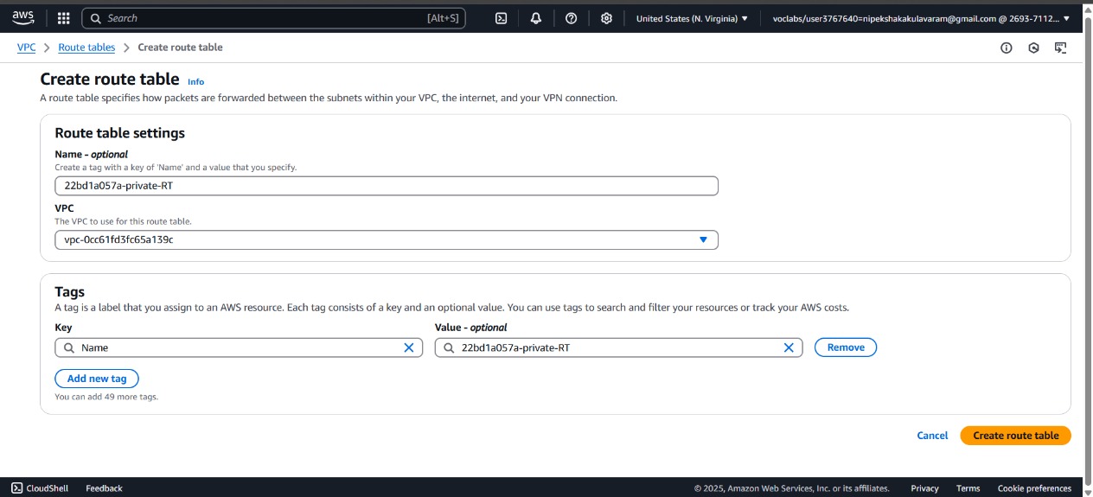

- Select 22bd1a057a-private-RT, Goto → Subnet associations → Edit subnet associations
- 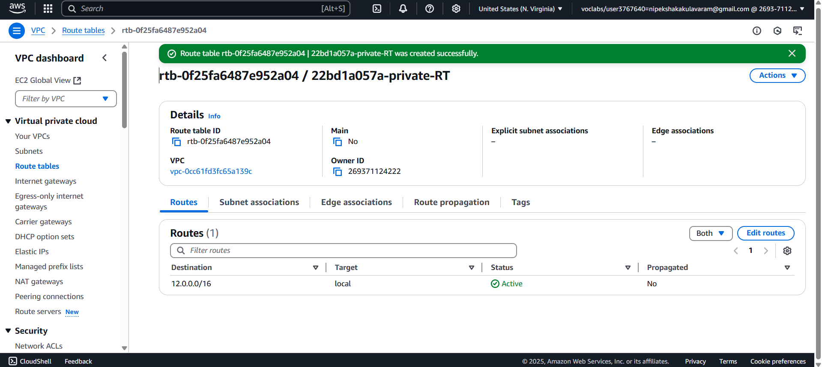

- Select 22bd1a057a-Private-SB2→click Save associations.
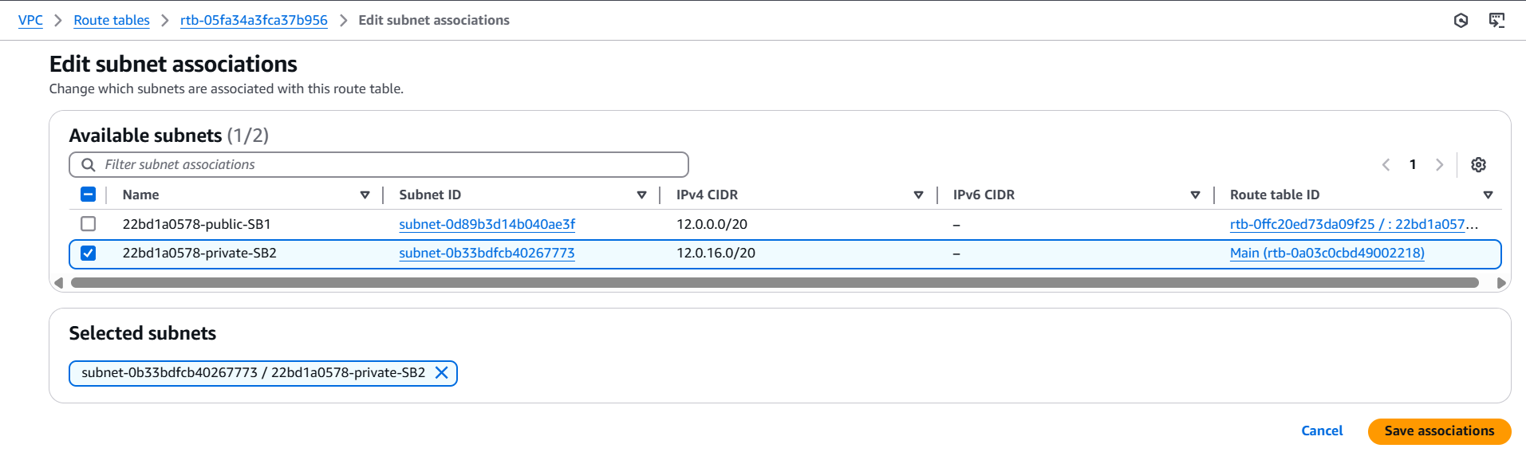
- Successfully updated.
- 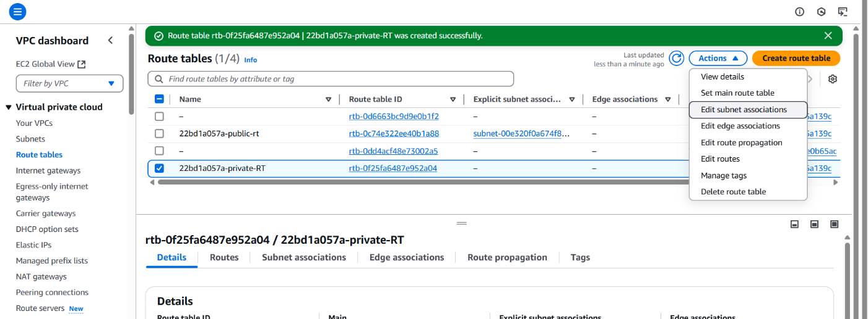

- Create a Resource inside the public subnet (EC2)
Navigate to EC2 → click on Instances
Create a Instance
- Name: EC1_22bd1a057a_Public_subnet-Instance
- Select : Ubuntu OS
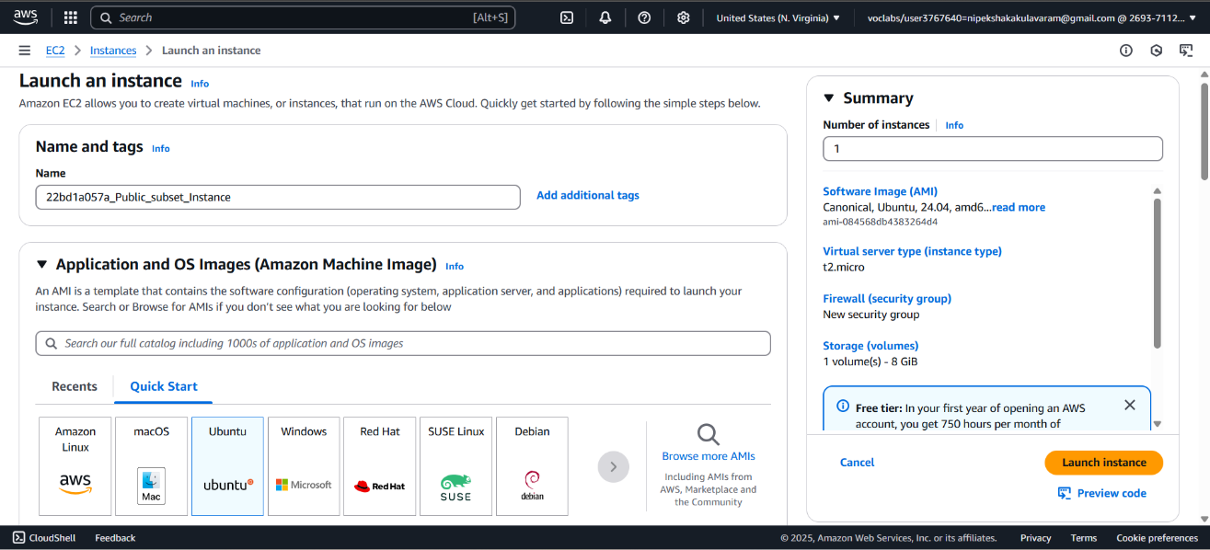

- AMI: Free Tier Eligible, 64 Bit,
- Instance type: t2.micro
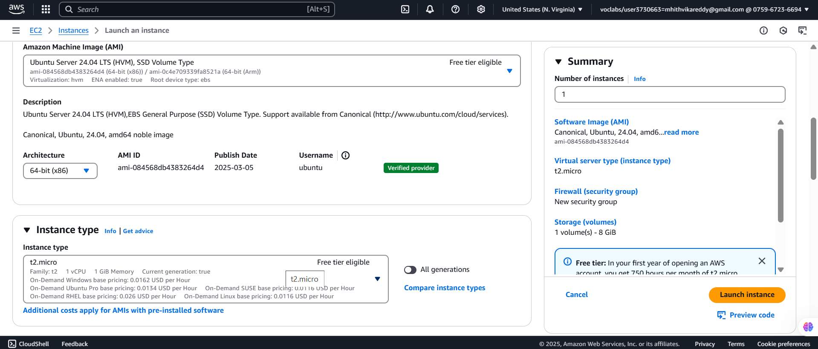

- KeyPair: PPK File
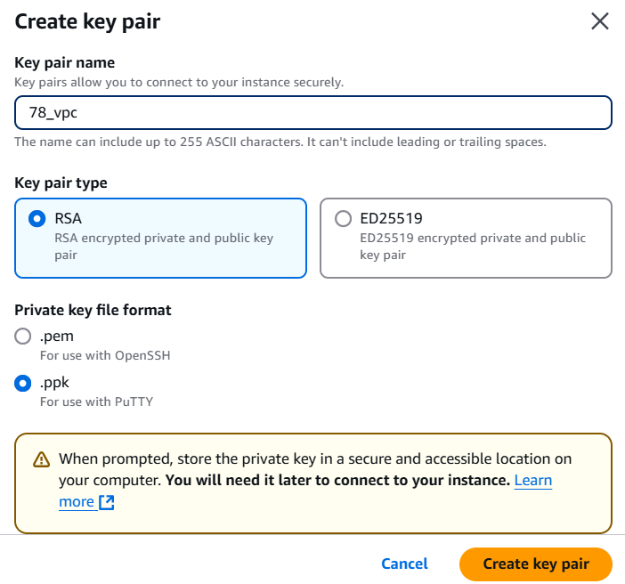
- Network Settings: Edit (Previous VPC Setup as to do Here..)
- VPC: Select which was created Earlier (22bd1a057a-VPC)
- Subnet : Choose public subnet (22bd1a057a-public-SB1)
- Auto-Assign public IP: Enable (To assign public IP)
- Firewall (Security Group) :
- Security Group Name: Public-22bd1a057a-ec2-SG
- Description: Same
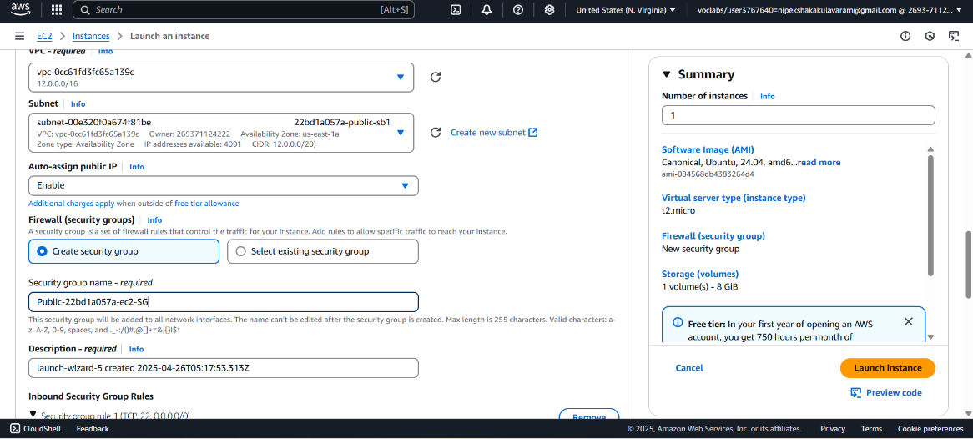

- Type: ssh, Protocol : TCP, PORT :22,
- Source Type: Anywhere
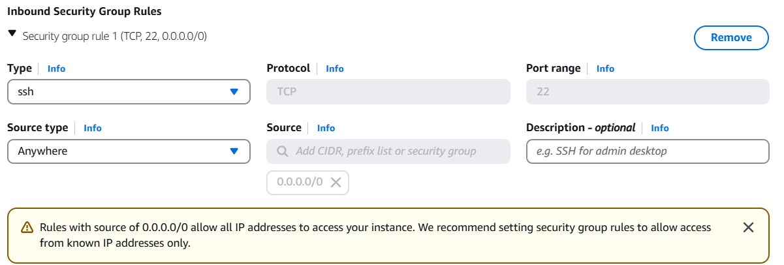
- Configuration Storage: Default
- Advance Details: Default
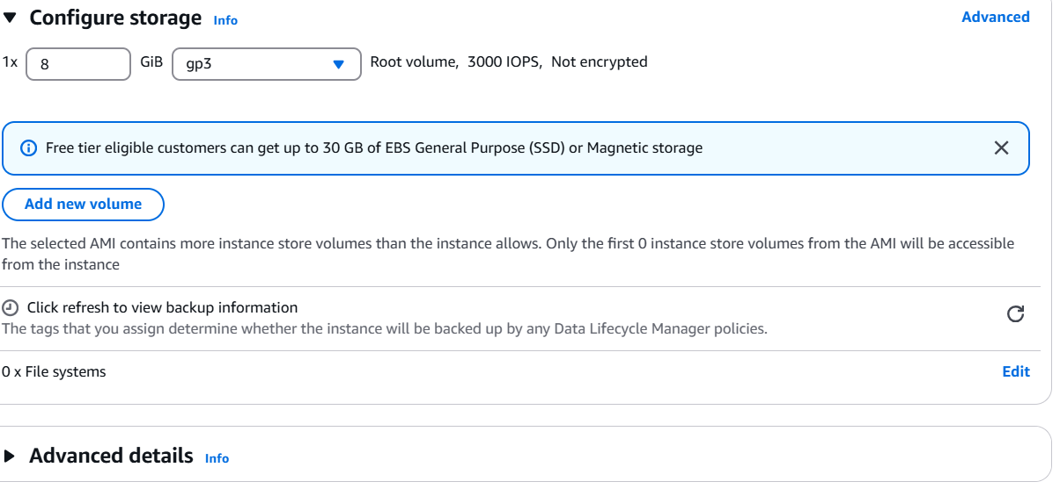

- Launch the Instance
- 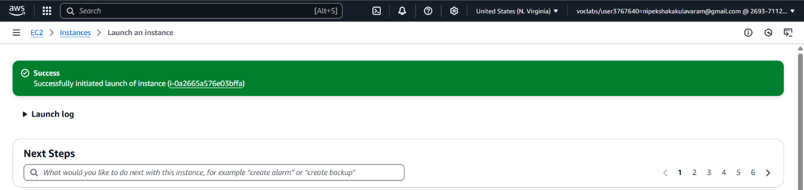

- Copy the Public Address
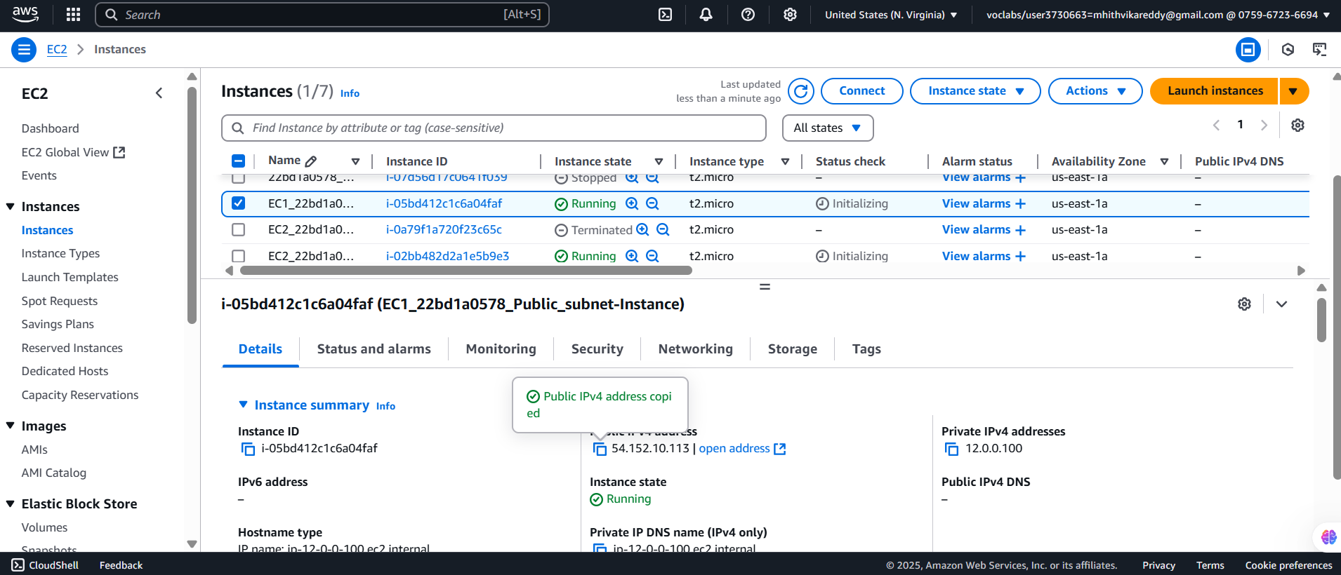

- Open PuTTY
In Host Name, enter the public IP of your instance (like ).
Port: 22 (default for SSH)

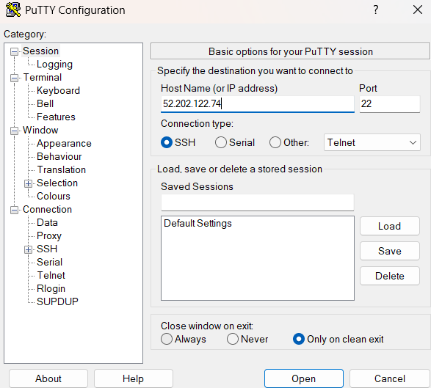

- Go to Connection → SSH → Auth → Credentials
Select your .ppk file
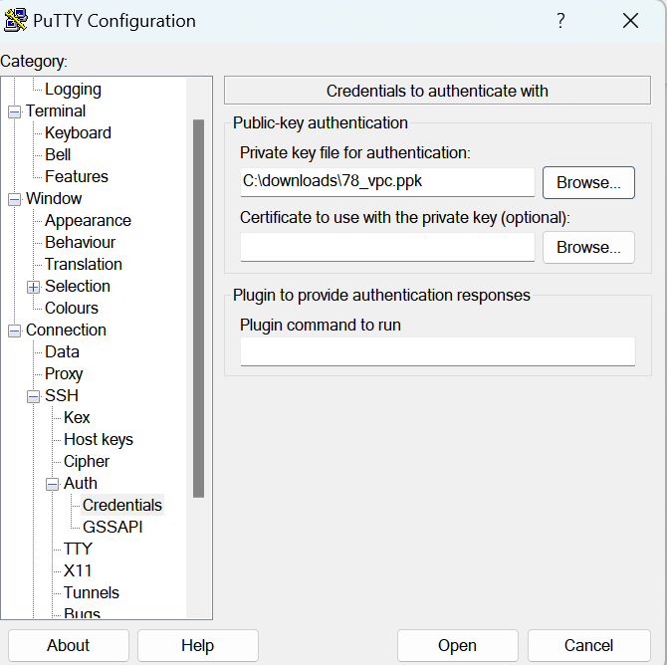

- Click Open → Accept the security alert

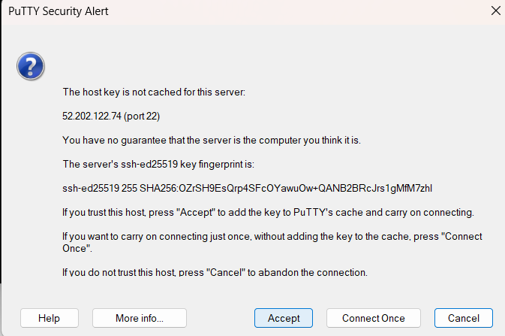

- Once connected/logged through putty you can check that we are connected with Public Address subnet

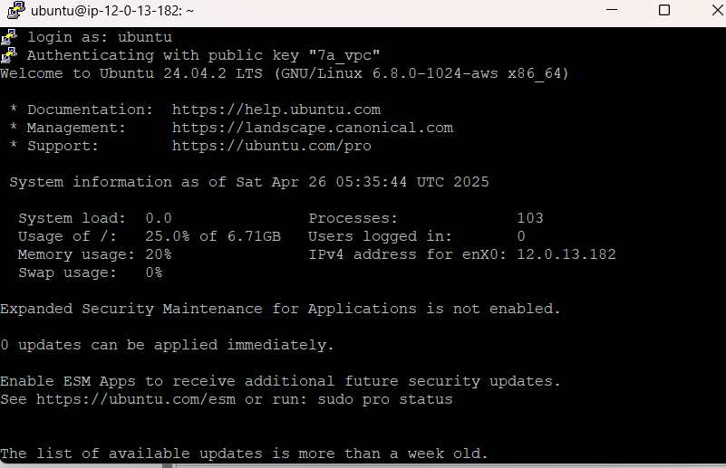

- Execute following commands
sudo apt install net-tools

sudo su -
curl ifconfig.me
hostname -I
Once connected/logged through putty you can check that we are connected with Public Address subnet (12.0.0.100)
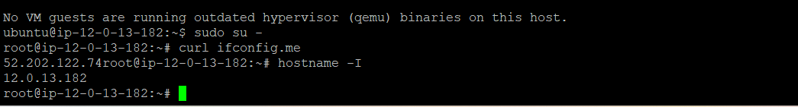

- Connect Private subnet with Bastion Host
Create a Instance
- Name: EC2_22bd1a057a_Private_subnet-Instance
- Select : Ubuntu OS
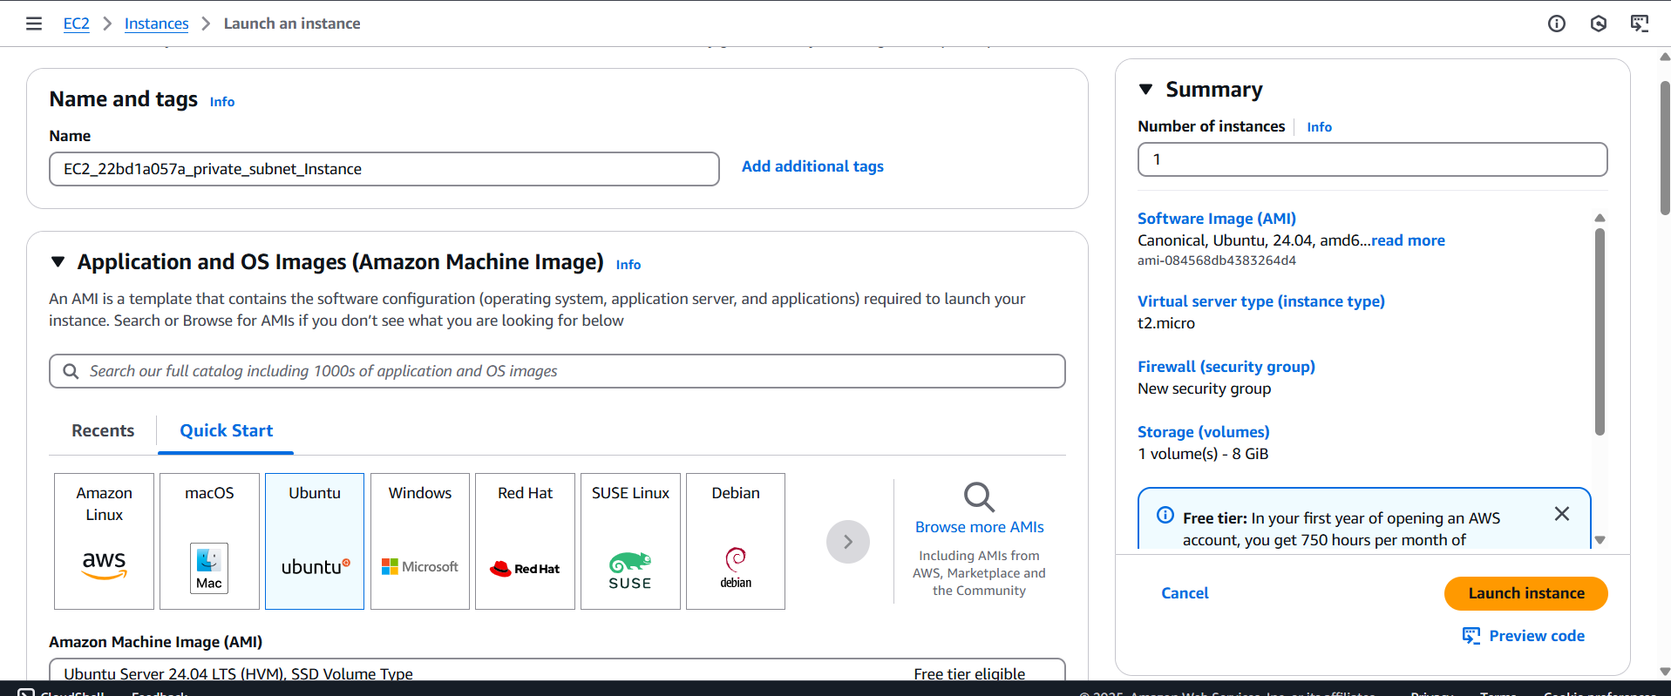

- AMI: Free Tier Eligible, 64 Bit,
- Instance type: t2.micro

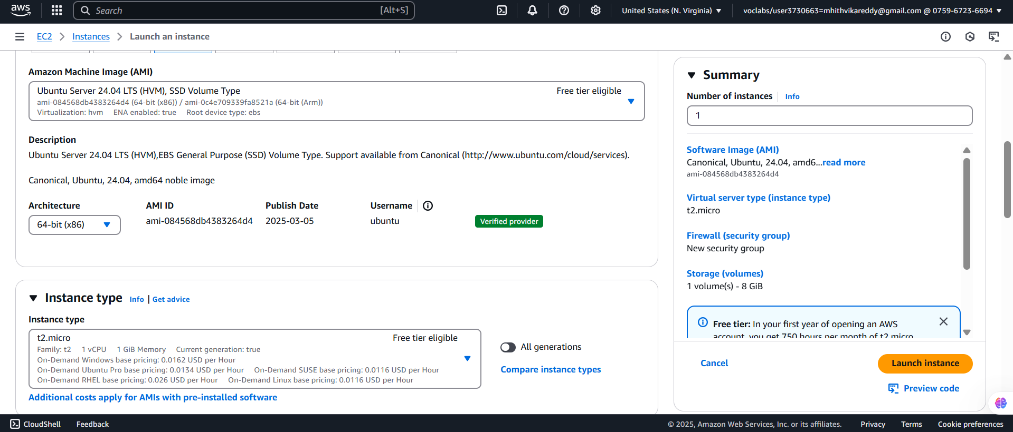

- KeyPair: PPK File(Already Exist_One)
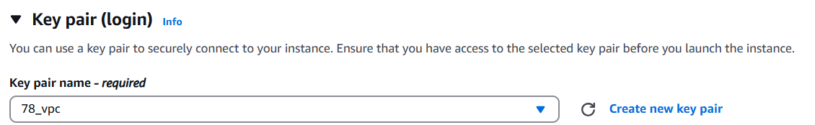

- Network Settings: Edit (Previous VPC Setup as to do Here..)
- VPC: Select which was created Earlier (22bd1a057a-VPC)
- Subnet : Choose public subnet (22bd1a057a-private-SB2)
- Auto-Assign public IP: Disable (No need public IP)
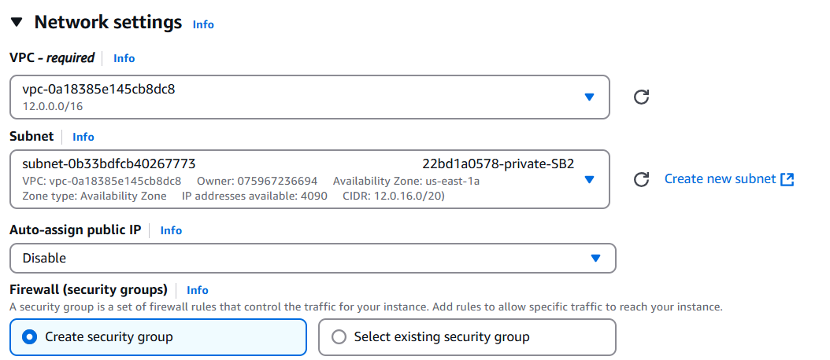

- Firewall (Security Group) :
- Security Group Name: Private-22bd1a057a-ec2-SG
- Description: Same as Private-22bd1a057a-ec2-SG
- Type: ssh, Protocol : TCP, PORT :22,
- Source Type: Anywhere
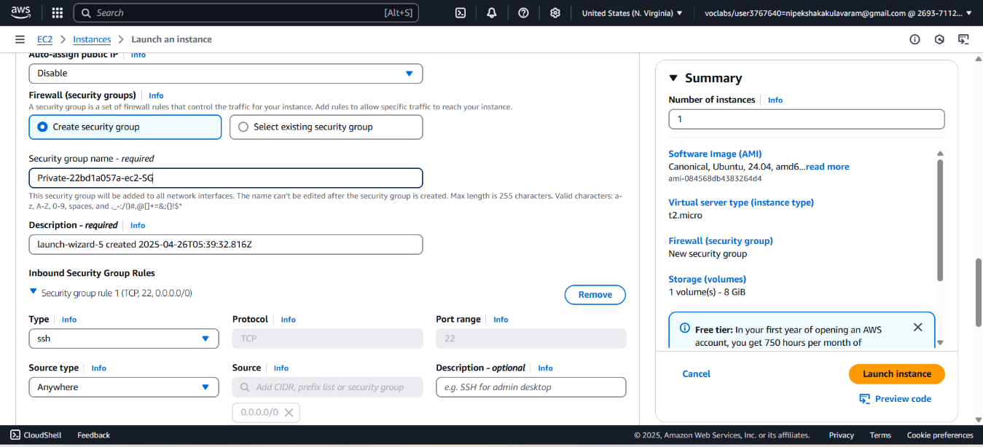

- Configuration Storage: Default
- Advance Details: Default
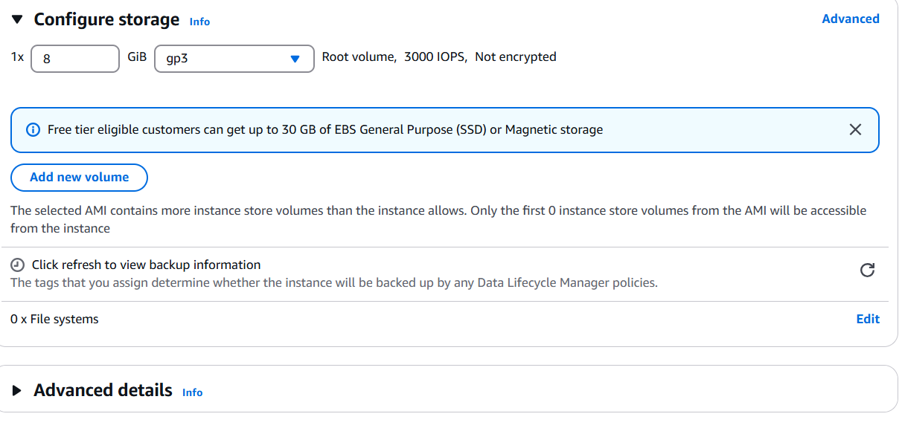

- Launch the instance

- Go to PuTTY Key Generator and Click on Load
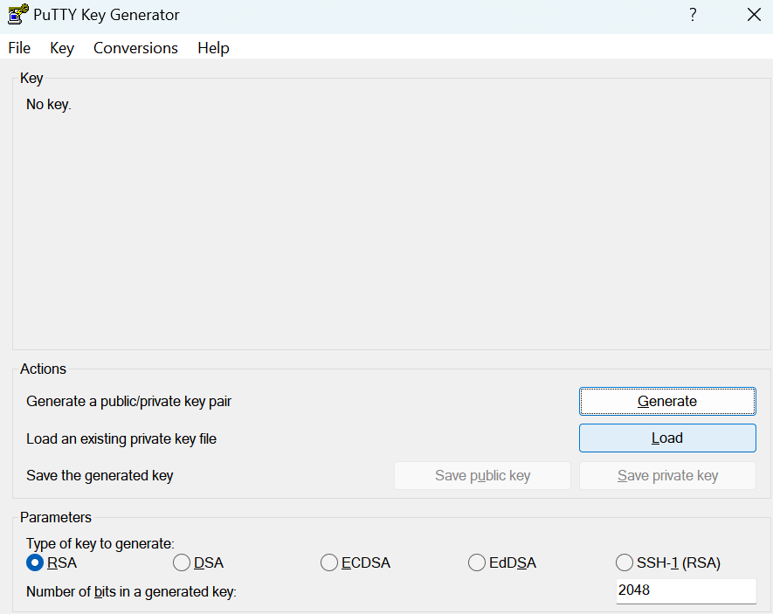

- Load your existing ppk file
- 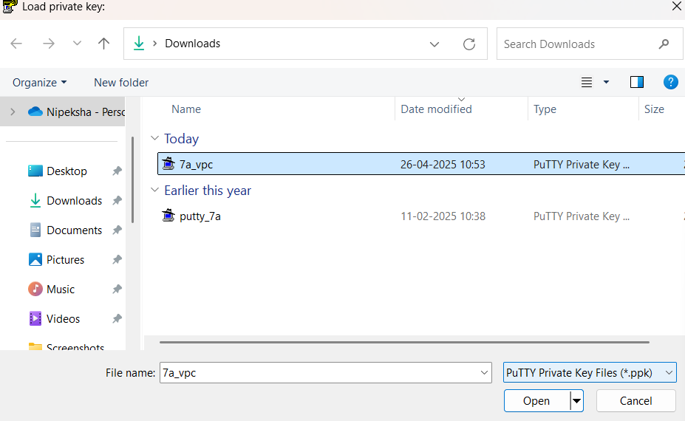

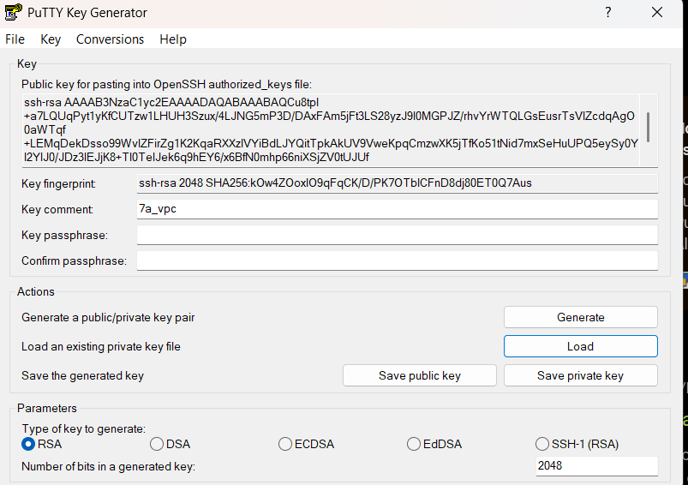

- Go to ->Conversions-> Export OpenSSH Key
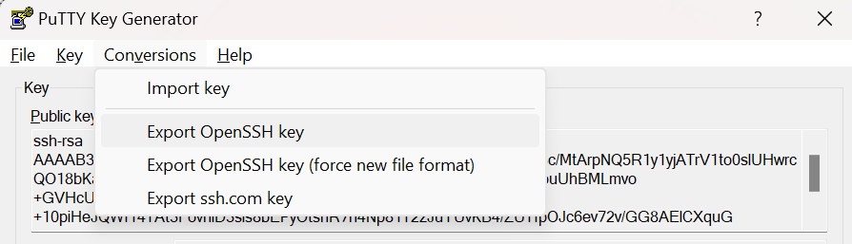

- Save our key as aws_privatekey_ec2.pem
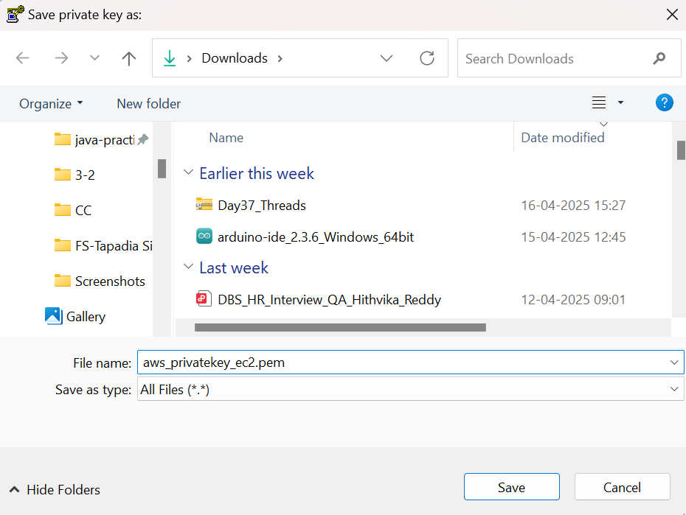

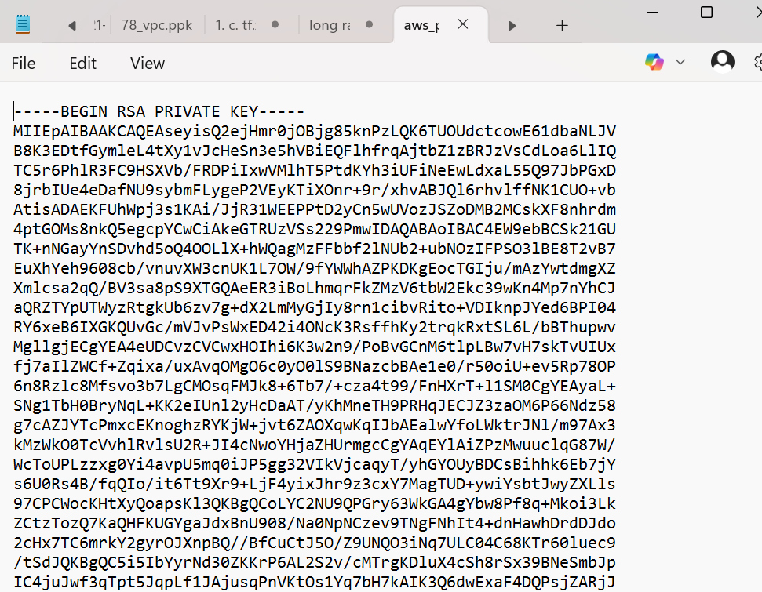

- Go to the putty we have opened before
Execute the following:

- Copy the key from the file we saved before
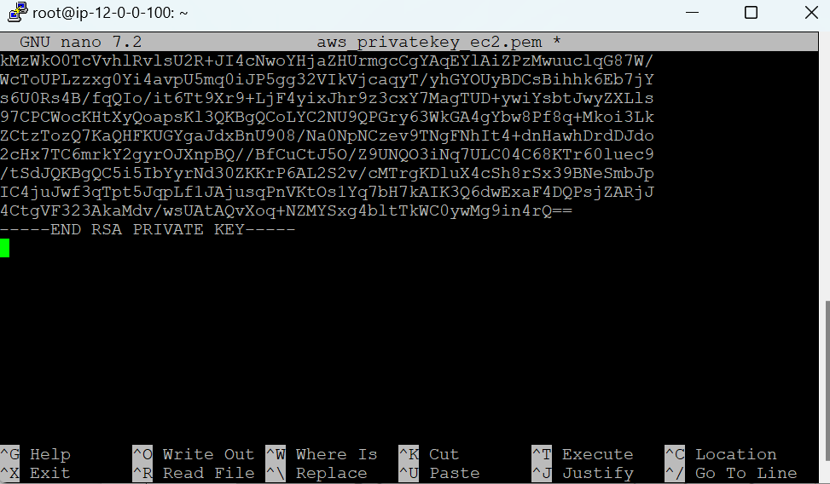

- Change the permissions
ls -l: to display the files present
ls -lart
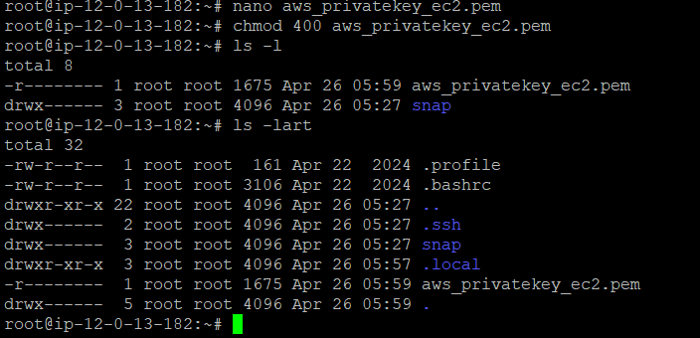

- Go to Private Instance (EC2_22bd1a057a_Private_subnet-Instance) Copy the Private address , it does not have public address
Copy the Private IPv4 address: 12.0.27.27
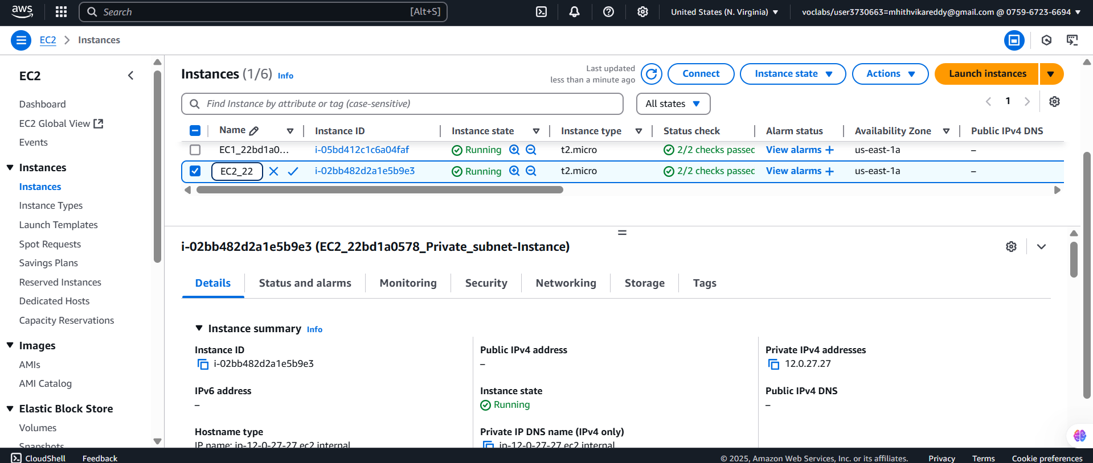

- Connecting public with Private
ssh -i aws_privatekey_ec2.pem ubuntu@Private_IP_address
ssh -i aws_privatekey_ec2.pem ubuntu@12.0.27.27
Select yes
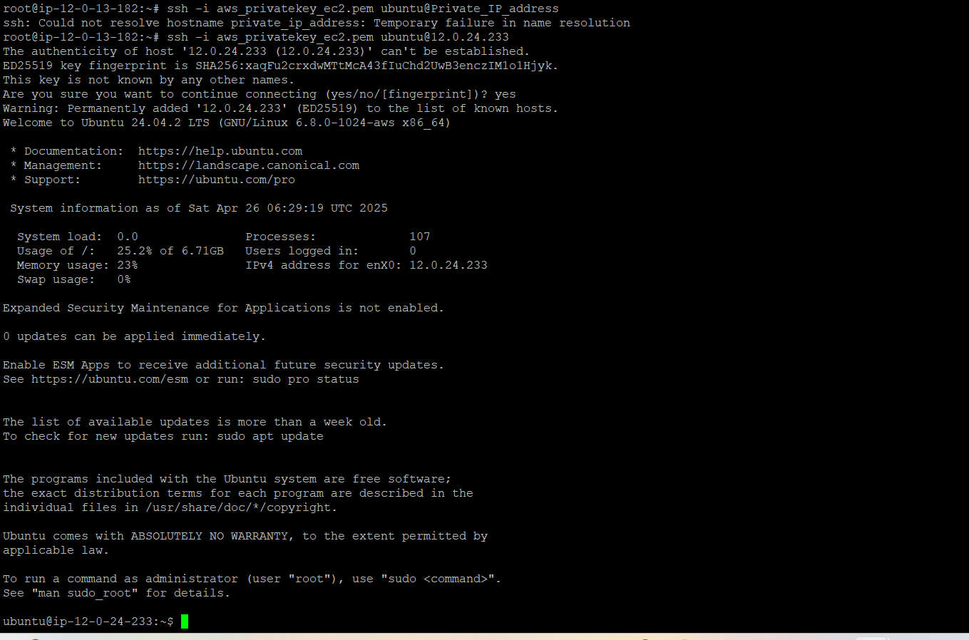

- Finally, you can see that you can enter into private EC2 with the help of Bastion Host

- Finally end the lab.
